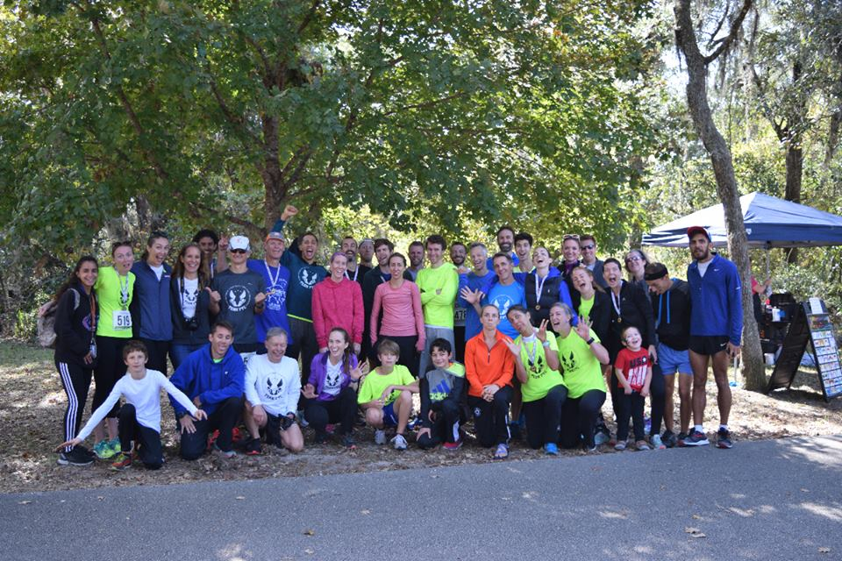 |  | Florida Track Club  - November Newsletter 2018!  - Issue Date
Club with the Orange on the singlet |  | CElebrating 50+ years as a Club!

October FTC Meeting Photo Recap
Orthopedic Sports Medicine Institute, 10/01/18
We had the pleasure of hearing from one of our board members, Patrick Gallagher at our October meeting. Patrick presented on “From Track to Trails and Back Again” and spoke from the heart on running experiences ranging from the 800 meters to the Western States Endurance Run. Thank you, Patrick!

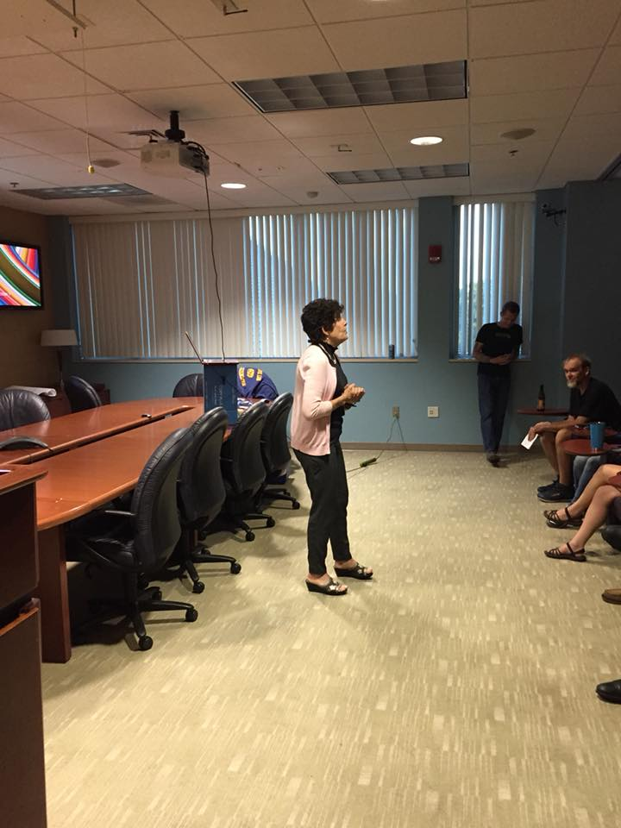
Immediate Past President Elizabeth Hanselman fills in for President Richard Garand with a welcome and club announcements.

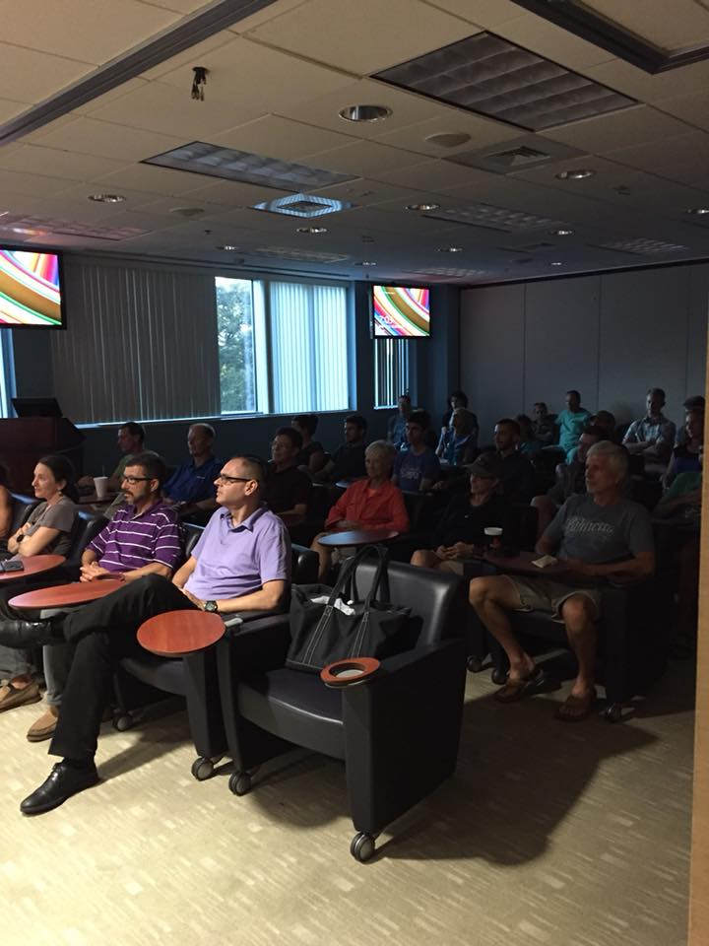
Full house for the October meeting.
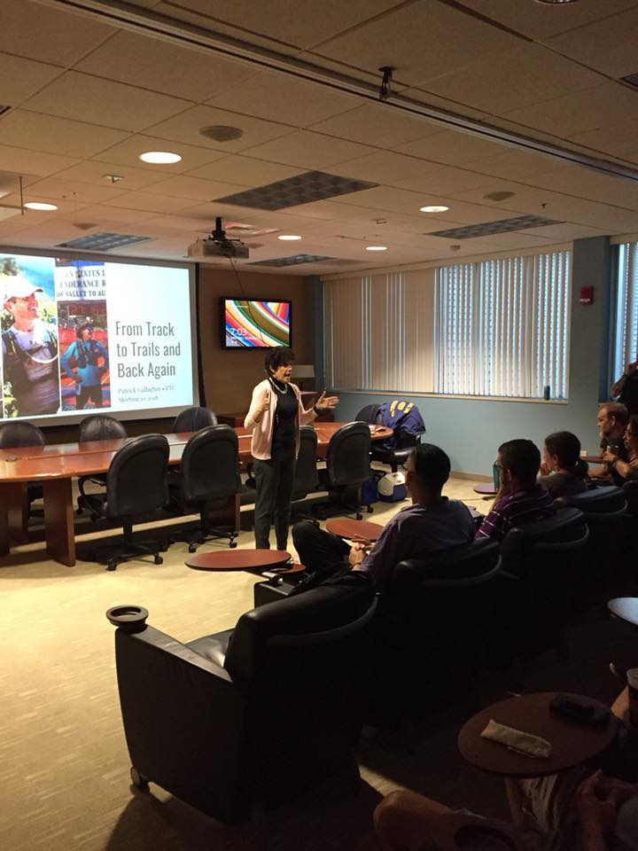
Elizabeth introducing Robb Eggleston who introduces guest speaker, Patrick Gallagher.
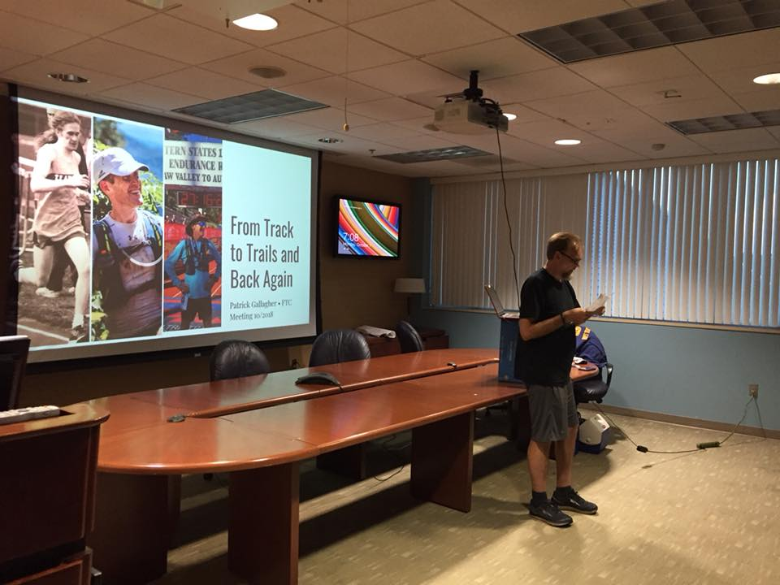
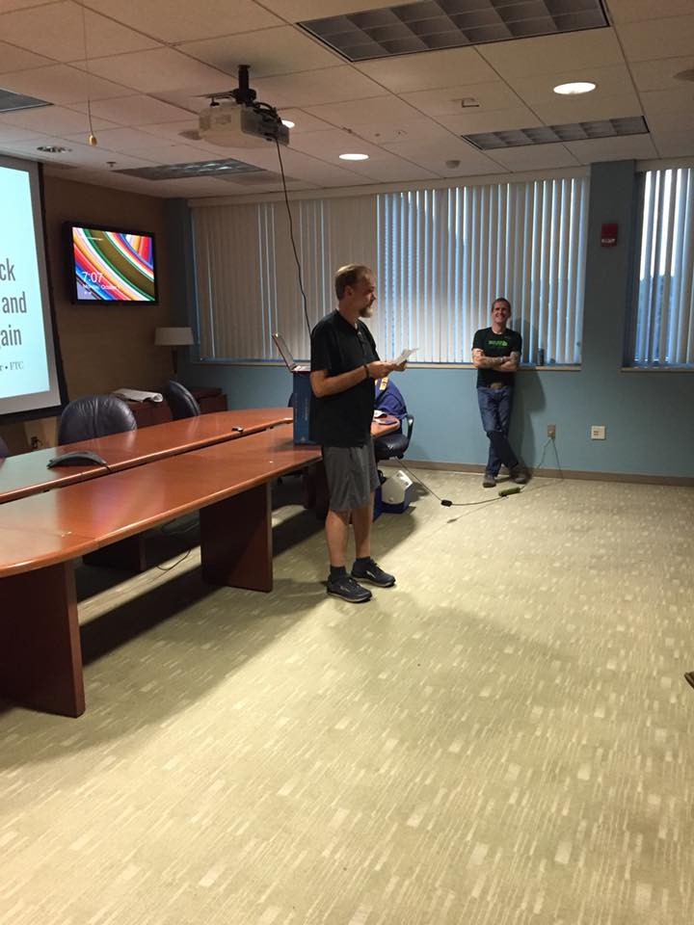
Robb introducing Patrick.
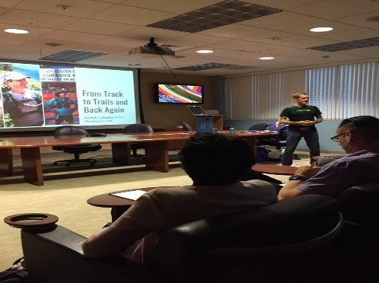
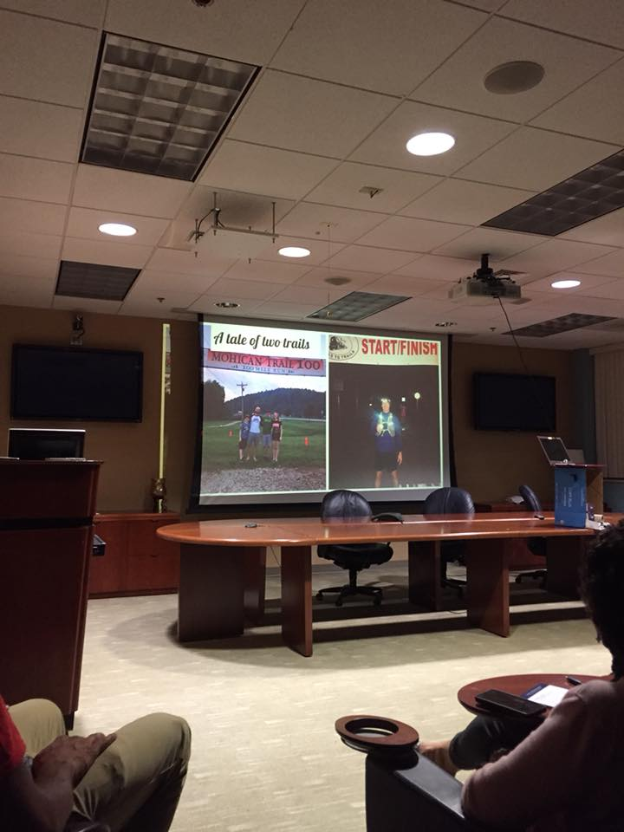
Photos from one of Patrick’s recent ultramarathons with his family spectating.
Thank you to Patrick’s sponsors, Lloyd Clarke Sports and The Athlete’s Den, for the raffle prizes!

Save the dates!
Frank Shorter Mile
December 31st 2018
4PM
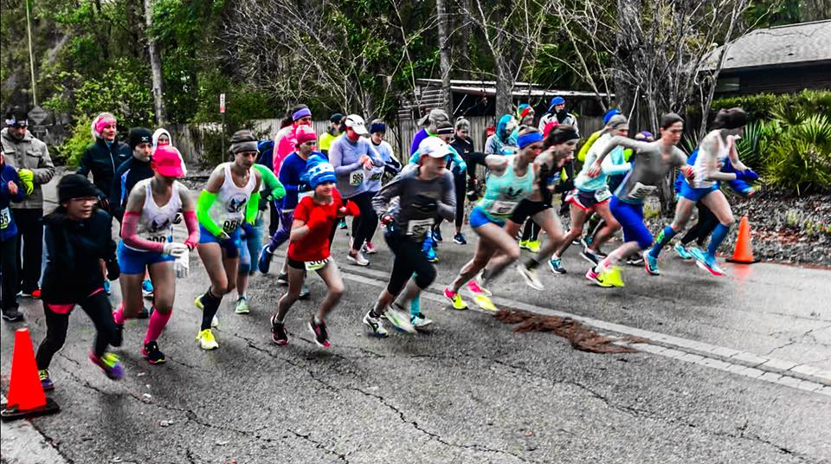
Same great course! Flat, fast, and spectator friendly. New date and time! End 2018 with the FTC and your fastest mile of the year!
Online signup:
https://runsignup.com/Race/FL/Gainesville/FloridaTrackClubpresentsShorter1MileRace
Paper Registration:
https://floridatrackclub.wildapricot.org/Blog/6892088
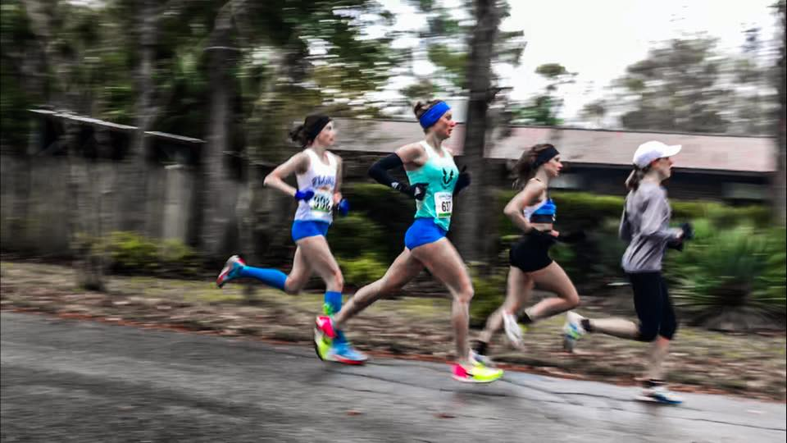
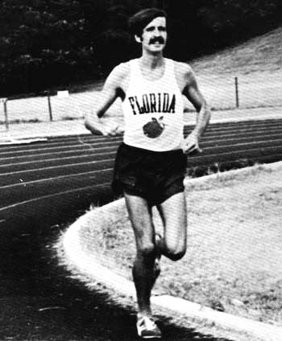

February 15-17, 2019
5 Points of Life Race Weekend
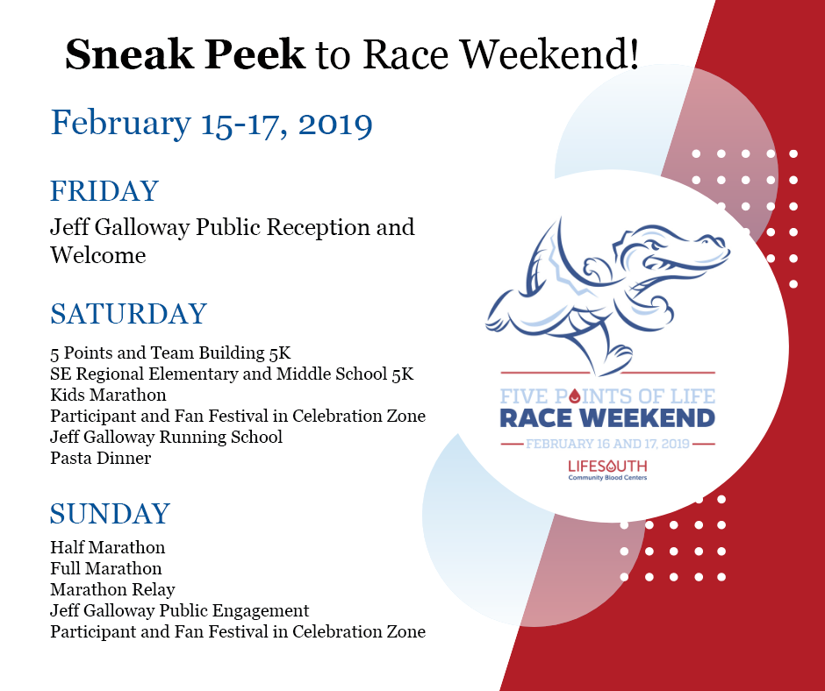

Running Group Opportunities in Gainesville
We are very lucky that on any given day during the week, you can find a reliable running group with whom to train. These groups are free and mostly run by volunteers. They offer great opportunities to network with other runners, learn about upcoming races and events, and they help share the burden of logging miles by yourself. Many groups have designated leaders that would be happy to answer your specific questions about each group. You can also email the club at thefloridatrackclub@gmail.com for more info.
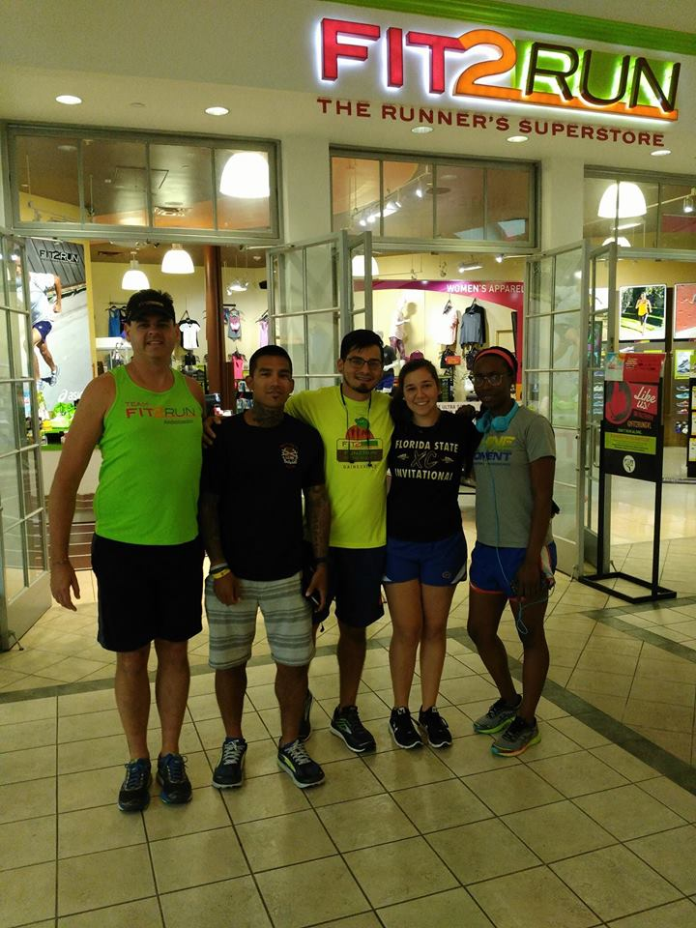
Saturday FTC Morning Long Run & Breakfast @ (Varies weekly) - 6:00 AM (spring/summer) 6:30 AM (fall/winter)
Long run (8 to 14 miles) various locations in Northwest and Southwest Gainesville
Contact Diane Miller (386-462-2384, dvmiller1@msn.com) since the location changes. Join the Gainesville Running Google Group above to get the weekly emails Diane sends out announcing the meeting location and route. The time changes according to daylight savings time (7 am in Fall/Winter) and (6 am in Spring/Summer). Between 6 and 15 runners do 8-14 miles at various paces and over different courses. This group of mostly FTC members does long runs each weekend in preparation for upcoming marathons. But you don’t have to be a marathoner to enjoy their company. After running, the group goes out for breakfast.

Sunday @ San Felasco Trail Run - 7:30 AM
Sunday Trail meets at 7:30AM for a 7:45 AM cool run under the trees. Several marked nature trails allow for name-your-own distance between 2 and 20 miles, the large group means you never have to run alone (unless you want!). All paces encouraged. San Felasco south entrance, 11101 Millhopper Road, Gainesville. Questions, contact Richard rjgarand@gmail.com

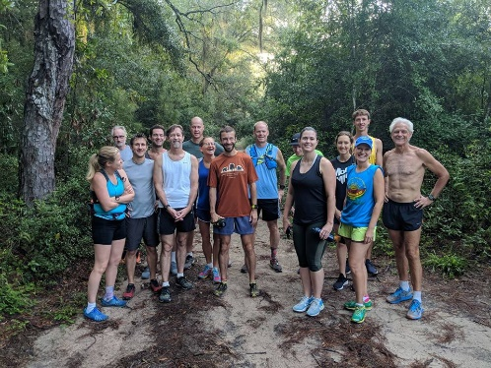
Mondays @ UF Stadium Fit2Run & Salty Dog Fun Run – 6:30 PM
The Salty Dog run on Monday Nights is about a 3.5 mile run (give or take; 3-4 miles), that goes through some cool parts of campus. It starts at Gate 6 of the Ben Hill Griffin Football Stadium, 6:30 PM. Runners get a free beer from Salty Dog afterwards. Contact Chase Chaser@fit2run.com or Natalie Nataliec@fit2run.com for details.

Mondays Lloyd Clarke Sports run from Cyprus & Grove – 6:30PM (Meet at 6:15PM)

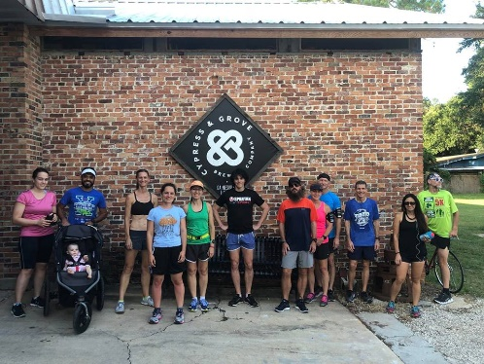
Tuesdays & Thursdays with TriGators at UF Percy Beard Track – 6:30AM
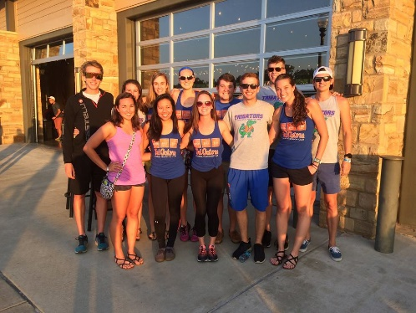
Tuesdays & Thursdays @ Kirkwood Running Group SW 13th St. and SW 25th Pl - 6:30 PM (fall/winter) 6:45 PM (spring/summer)
Meets at 6:30 pm in Fall and Winter and 6:45 pm in Spring and Summer. We meet in the parking lot on the corner of SW 13th St. and SW 25th Place and run the 3 mile course of the former Literacy Run. Some of us run it twice or add other variations for more miles. The course is shady with low traffic. The group consists of runners of all abilities and all ages and is open to anyone. Contact Rick Swenson: phone 352.336.7798 or email raswenson53@hotmail.com

Tuesday @ Tioga Town Center - 6:30 PM
Contact Kevin Love if you’re coming for the first time. imnotthatkevinlove@gmail.com

Tuesday @ UF Stadium Steps and Ramps – 5:00 PM
5:00 PM 1/2 hour of cardio at the UF Football Stadium. Contact Stadium Stompers a.k.a. Barry Murphy (352-672-0756). This is a half-hour cardio workout of stadium steps! Our group meets at Gate Four of the stadium and walkers, joggers, and runners are encouraged to come.

Wednesday @ Oaks Mall Fit2Run - 6:30 PM
Come run with us at an “All Welcome” FunRun at Fit2Run conveniently located in the Oaks Mall. Every Wednesday evening @ 6:30pm. 6:15 early birds get to get that stretch in and hydration and nutrition beforehand. Enjoy your choice of pace and selected routes to run!! Distance varies and feel free to choose which distance is best for you. Contact our event coordinator at eventsgainesville@fit2run.com

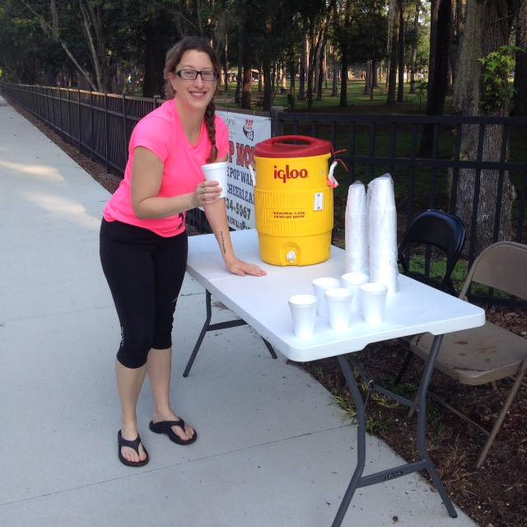

Wednesday @ First Magnitude Brewery - 6:30 PM
Contact Kevin Love if you’re coming for the first time. imnotthatkevinlove@gmail.com
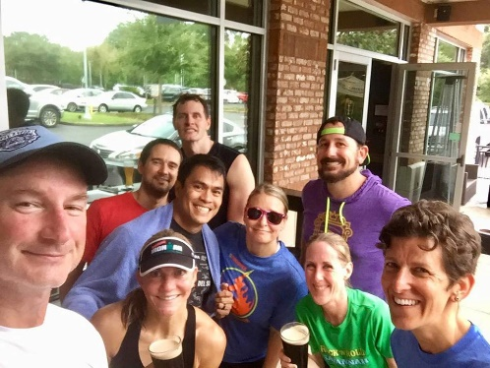

Thursday @ Tipples - 6:00 PM
Meets at Tipples on the corner of SW Tower Rd and 24th Ave. 4 mile route with paces ranging from 8-12 minute miles. Come join us for plenty of conversation and camaraderie. Stick around to grab a beer at Tipples afterwards. Currently meeting at 6:00 and heading out on run at 6:15. The pace ranges from 8:00 to 12:00/mile.
http://www.mapmyrun.com/run/united-states/fl/gainesville/600127990866414223
Group time may change so touch base with Kevin if you’re coming for the first time. imnotthatkevinlove@gmail.com

Tom Walker Memorial Half-Marathon and Keith Brantly 5k – Pre-Registration ends Wednesday 11.7.18
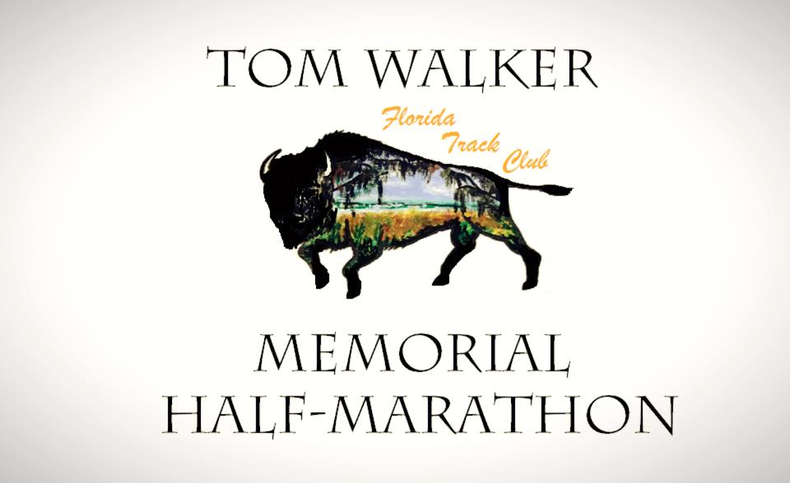

Sunday, November 11th
8AM Bouleware Springs Entrance
Hawthorne Trail
https://runsignup.com/Race/FL/Gainesville/TomWalkerMemorialHalfMarathon?remMeAttempt=
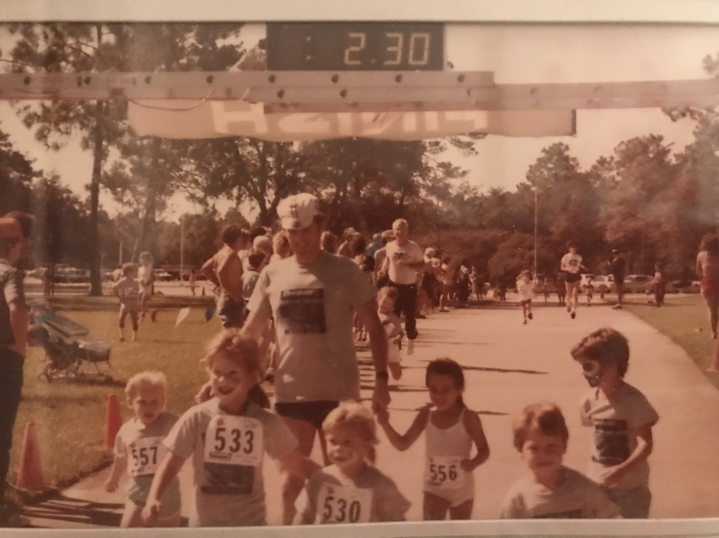
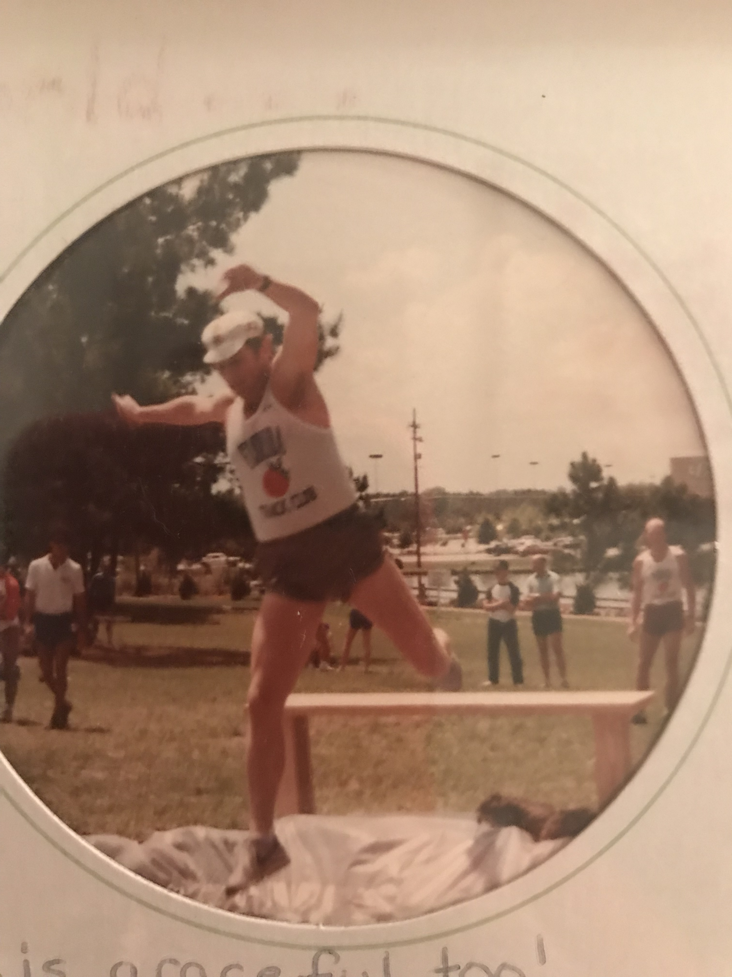
The half marathon race is in memory of our former FTC president, Tom Walker, who served in that capacity for the years 1984-85. He was described in FTC newsletters as a tireless worker for the club and "worked almost every race, and he would get the results printed and mailed out to each runner."
For a number of years, he and his training partner, Nick Holler would do 20-miles on the hilly dirt roads of Micanopy with the goal of breaking 3 hours in the marathon. Eventually, according to Holler, there was a photo in Tom's office of Tom going under the clock at the Chickamuaga Marathon. The clock read 2:56.
While doing what he loved, running, Tom died of a heart attack at the age of 38 in June of 1989. Leaving behind a loving family (who were so generous to share the following photos of Tom). Join us on Sunday, November 11th on the Hawthorne Trail in a celebration of life and health.
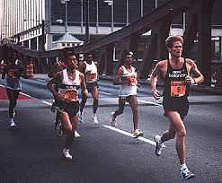
Keith Brantly, far right, former FTC President and 1996 US Olympian road racing in the 1990s. We have named the 5k portion of our race weekend in his honor.
Our Keith Brantly 5k (to be held in conjunction with our Tom Walker Memorial Half-Marathon on 11/11/18) is also named for an important figure in the history of U.S. running as well as the Florida Track Club.
Brantly originally came to Gainesville to attend the University of Florida, then stayed to train and eventually established himself as one of the most successfull and profilic competitors in the country, with a career spanning more than three decades.
Keith not only represented the United States in the 1996 Olympic Marathon (finishing 28th in 2:18:17) but also is a 12-time member of US National track, road racing, and cross-country teams, an 8-time individual national road racing champion in the 10k, 20k, 25k, and the marathon, and a 5-time U.S. Olympic trials participant in events ranging from the 5k to the marathon.
Keith also served as FTC president from 1990-1991 and helped organize and race direct (and compete in!) the hugely popular Great Gainesville Road Race. Volunteering and giving back to the running community is also an important part of Keith's legacy. He works with programs such as Athletes for Hope, U.S. Olympic Team Mentoring Program, as well as with his wife, elite runner Kim Pawelek works with RunWell - a nonprofit organization dedicated to replacing addiction with healthy lifestyles.
We are honored to have both Keith and Kim coming to the race this year! Sign up to run with them! You will also have a chance to meet and chat with Keith and Kim at our after-party.
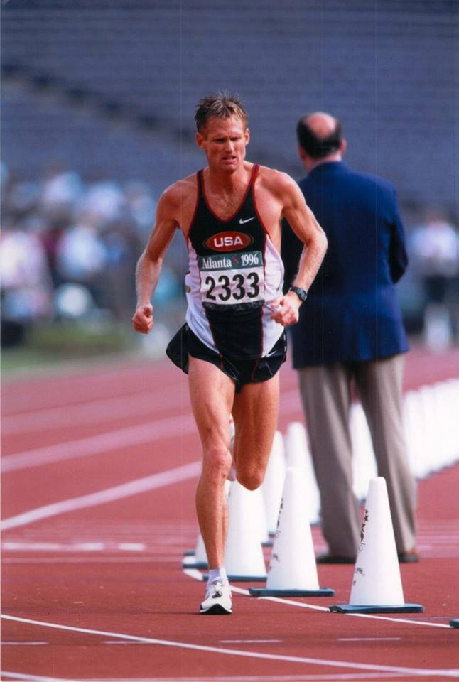
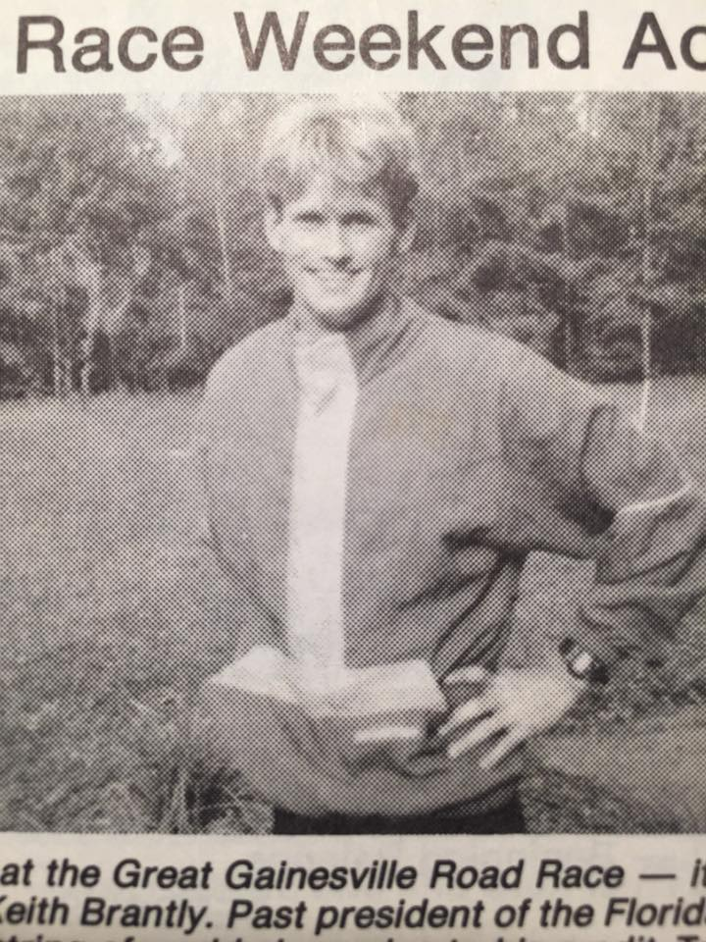
Race Day Fun!
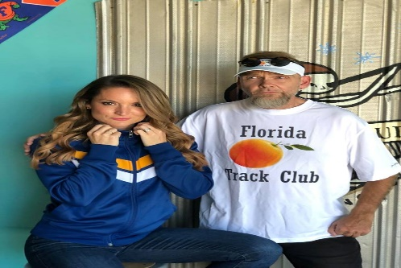
Local personalities Robb Eggleston and Georganne Watson will be on site to give race announcements and running commentary!
Our race sponsor, BMW of Gainesville will be furnishing a BMW pace car!
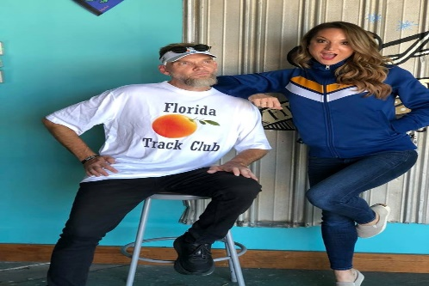
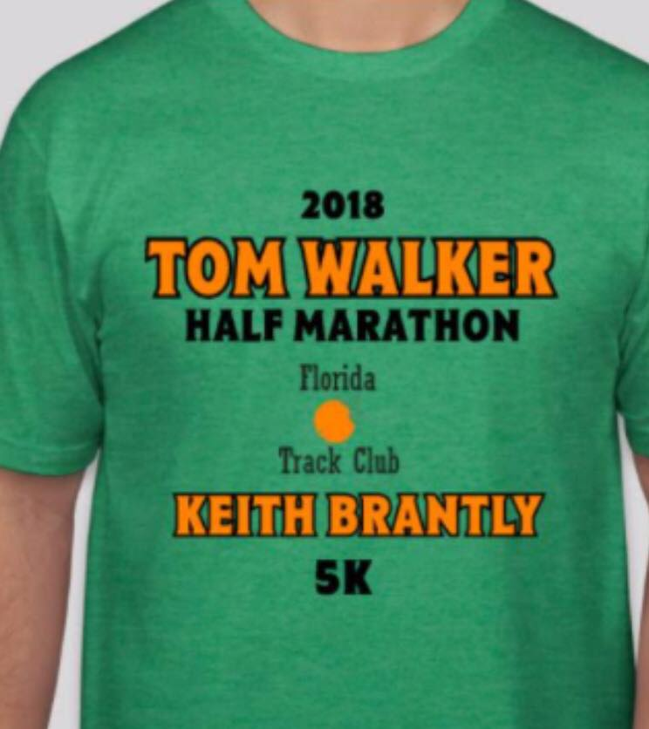
Race Tshirts will be guaranteed to first 250 registrants. We have both men’s and women’s sizes available.
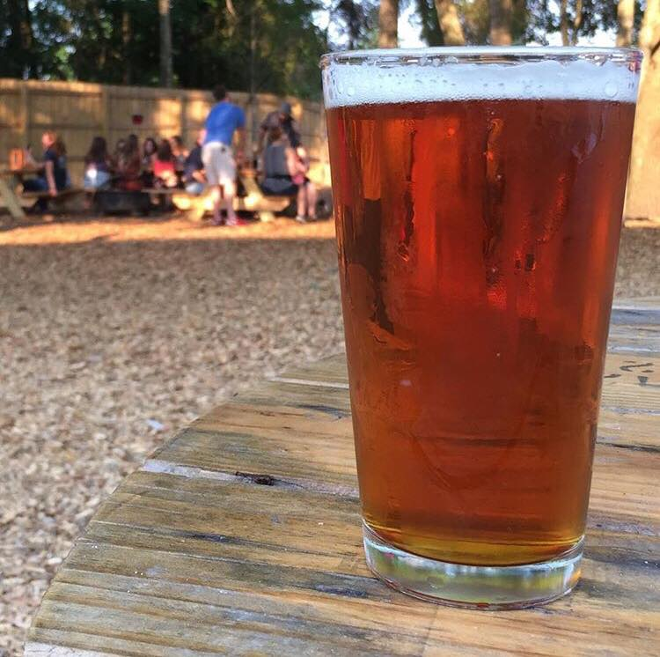
All racers will receive a free drink ticket for the after party at First Magnitude Brewing Company!
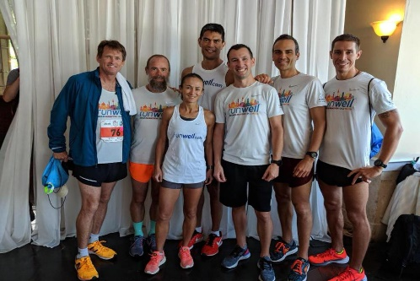
Keith Brantly challenge:
To add a little MORE spice to the 2018 Tom Walker Memorial Half Marathon and Keith Brantly 5K on November 11th, I’m offering to donate to the Florida Track Club $1.00 for every runner who finishes the 5K ahead of me. To spice things up EVEN MORE, I will be the last person to start the 5K essentially giving everyone who runs the race a head start so there’s no need for kicking, punching or tripping me after the starting line….unless I pass you during the race, then you can try to trip me. And….if that’s not enough, regardless of how many people show me their heels at the finish line, my wife Kim Pawelek and I will make a minimum donation to the Florida Track Club of $100.00.
So here’s your opportunity to run a fun race, have a chance to be philanthropic AND have bragging rights that you beat an Olympian, albeit an old, slow Olympian! As a side note, there’s probably no need to trip me if I pass you during the race as I do a pretty good job of tripping over just about anything…or nothing….all by myself.

Our FTC board of directors elections will be held on SUNDAY, NOVEMBER 11th at the Tom Walker Half Marathon and Keith Brantly 5k as well as at our race after party at First Magnitude (12-2pm). If you would like an absentee ballot, please email thefloridatrackclub@gmail.com by noon on Friday.

This chip-timed USATF-certified course and is on a wide paved path with plenty of shade.

Florida Track Club members receive a discount ($5 off half marathon, $3 off 5k) at checkout. Kids 13 and under receive reduced pricing as well.

$250 cash prize to Male and Female overall winner, $100 cash prize to 2nd place Male and Female, $50 cash prize for 3rd place Male and Female. All half marathon finishers will receive a custom finisher's medal.
Due to popular demand we are continuing the 5k race that debuted in 2016 as well! This year, we will inaugurate the race as the Keith Brantly 5k in honor of our previous FTC president and US 10k Olympian.
Awards (trophy or medal, TBD) to first place male, female, and masters male and female.

Early race number and shirt pickup will take place at First Magnitude Brewing Company on Saturday, November 10th from 12-2PM. Day of race pick up begins at 7 am at Boulware Springs. Race shirts will be available until they run out, so we encourage you to register early.

Contact a race committee member with further questions:
Mark Ou markieou@gmail.com
Betsy Suda betsysuda820@gmail.com
Nic Armfield narmfield@gmail.com

Register today! FTC members get $5/$3 off at checkout!
https://runsignup.com/Race/FL/Gainesville/TomWalkerMemorialHalfMarathon?remMeAttempt=
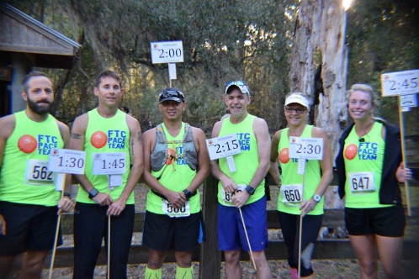
Pace team members: Christopher Reisch, Richard Smith, Timothy Donovan, Keith Singleton, Laurie Meyers, and Jenni Johnson

FTC Hats and Visors back in stock!
$20 each and available for purchase at packet pickup and at the Tom Walker Races.
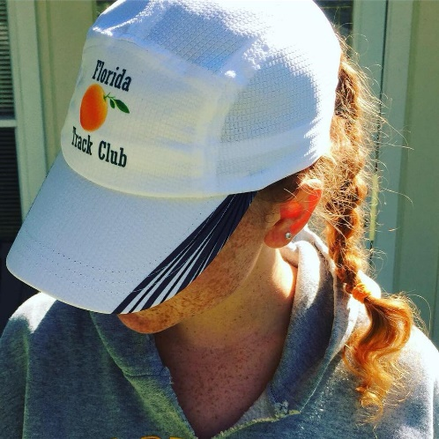

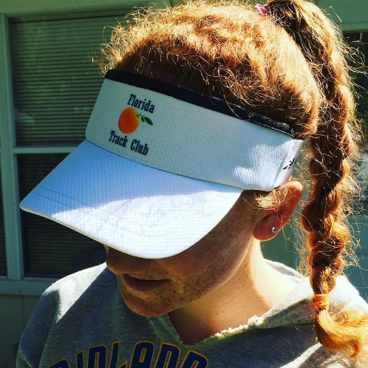

History of the Florida Track Club
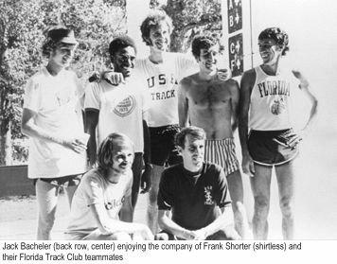
By Felicia Lee
felicialeewrites@gmail.com

Florida Track Club
The Florida Track Club (FTC) is the oldest continuously operating track club in the U.S.^{[6]} It is known not only as the home and training base for prominent runners such as Olympic gold medalist Frank Shorter, Jack Bacheler, and Jeff Galloway,^{[6]} but also for setting important precedents for modern track clubs: FTC was the first track club in the U.S. to be granted tax-exempt status, and the first in which competitive athletes had the majority vote on who would go to meets and where they would go.^{2]} FTC was also largely responsible for establishing its hometown, Gainesville, Florida, as a mecca for serious competitive runners.^{[6]}
The Beginning
FTC was founded in 1965 by University of Florida and Olympic track coach Jimmy Carnes and Jack Gamble in Gainesville, Florida. Upon moving to Gainesville in 1965 for his career in environmental engineering, Gamble, a former college track and field athlete who wanted to stay involved in the sport, reached out to Carnes and volunteered to officiate and otherwise help out at events. The two started an informal group in which Gamble would recruit prominent runners to give talks.^{[1]}
One day, Carnes asked Gamble if he could help raise money to send a team to a relay race at Madison Square Garden in New York—he’d been expecting a check, but it hadn‘t yet arrived. Gamble immediately started fundraising among other runners at the University of Florida and brought the money he’d acquired back to Carnes.^{[1]} However, by that time, the check Carnes had been expecting had arrived. Since most of the donations Gamble had solicited were in cash, and he hadn’t kept track of who had donated what, he couldn’t return the money. Carnes and Gamble felt obligated to put the funds to good use for the running community.^{[1]}
Gamble consulted with Ed Singley, a colleague from work who had experience setting up organizations and handling finances. By the end of the day, the Florida Track Club had come into being, with Carnes as its executive director, Gamble as its president, and a bank balance of around $800.^{[2]}
Soon after, Carnes and Gamble met with a number of other local runners at Gamble’s house to develop a plan and a vision for the club. Besides being accomplished runners, many of those attending this first meeting brought useful professional skills to the club’s founding.^{[2]}
One of them, John L. Parker, Jr., had a law degree and used his legal skills to draft an official charter for the club. (Parker’s novel Once a Runner, a cult favorite among runners, is a lightly fictionalized account of the early years of the club.)^{[4]} Another, Olympic distance runner Jack Bacheler, designed the club’s logo, an image of a Florida orange, making a point of ensuring the image in the logo was botanically accurate.^{[2]}
An innovative feature of the club was that it was organized so that a majority of the board would be competitive runners, and these runners would decide who got club support to attend meets and which races they’d attend. This strategy was designed to ensure the best athletes for each event would get support and avoid the political favoritism that occurred in other clubs. This policy was unique among track clubs of the time.^{[2]}
Gamble stayed president for about 3 years, after which time the club instituted regular elections.^{[1]}
The Early Years
During Carnes’ years coaching the club, he noticed his runners tended to be in better condition during indoors winter meets than runners from northeastern schools. He attributed this to Florida’s weather, which allowed for long outdoors workouts during the winter.^{[3]}
But Florida’s punishingly hot and humid summers also proved a useful training tool. In the 1968 Summer Olympics in Mexico City, Jack Bacheler, an early club member and top-ranked two-miler, was the only U.S. runner able to run strongly enough at Mexico City’s high altitude to qualify for the finals in the 10,000 meters.^{[3]} Unfortunately, he was selected for random drug testing after the qualifying race and when unable to produce a urine sample, was coaxed to drink some local water offered by race officials. The unpurified water gave him such severe digestive distress he was unable to compete in the finals.^{[3]}
Nevertheless, serious runners took note of Bacheler’s success in the preliminary races, which Carnes attributed to Bacheler’s training regime of two or three daily runs in Gainesville’s summer heat—this apparently gave him the conditioning he needed to run efficiently at high altitude. Other serious competitive runners, wanting to replicate his success, soon began moving to Gainesville and training with the FTC.^{[1]}
By the 1970s, the FTC had become the training home to such prominent runners as Jeff Galloway, Frank Shorter, and Barry Brown. In 1970, the year Shorter joined the FTC, the club won its first national championship at the Track and Field Federation meet. In 1971, FTC won its first AAU cross-country championship and retook the title twice, in 1972 and 1973.^{[5]}
After Shorter took the gold medal in the marathon in the 1972 Summer Olympics in Munich, the club’s popularity exploded—as did serious interest in long-distance running. It was during this era that Gainesville became known as a mecca for elite competitive runners.^{[1]}
At this time, competitive running adhered to a code of strict amateurism—runners could not receive any compensation for their running apart from payment of their expenses. The mere suggestion of an improper gift or excessive reimbursement of expenses was sometimes enough to get a runner banned from competition. To help FTC runners support themselves while adhering to this standard, Gamble arranged part-time landscaping maintenance jobs for them with UF’s Plant and Grounds Department. He also arranged for local hotels to let runners stay in unoccupied rooms. Carnes, who owned some investment properties in Gainesville, opened some of them to runners as well. In addition, Gamble even had some runners stay with him in his own home when first arriving in Gainesville.^{[1]}
On top of his running achievements, Shorter also changed track and field history by forcing a change in the longstanding policy of strict amateurism for runners. After becoming a household name, he began manufacturing and selling running gear and pushed back when told he couldn’t wear one of his own branded shirts.^{[1]} Realizing the absurdity of this constraint, officials relented, and the policy of strict amateurism soon ended, paving the way for today’s professional running circuit.^{[1]}
Women in the Early FTC
While the initial group of runners in the club were men, a few serious female runners were also active members of the club in its early years. The most prominent of these was Margaret Tolbert, who, along with her sister, Jane, had been tennis players UF, but also had an interest in running. Opportunities for women to run competitively at the college level were limited at the time, and the longest race available to them was 1 mile, which put Tolbert, whose aptitude was for distance running, at a disadvantage.^{[1]} Moreover, track training for women was constrained by the small number of women interested in running as well as conventional standards of femininity.^{[6]}
The FTC runners, however, were welcoming and supportive of her efforts, and she made a point of keeping up with them in their workouts.^{[6]} This was initially a challenge, since she started running with them in her teens and most of the other runners were men in their mid-20s. In addition, she participated in an informal group of noon runners that included FTC members and non-members and both men and women.^{[6]} This experience offered her access to cutting-edge training as well as the financial support to compete in prominent races. Because of her rigorous training and mentoring from other FTC members, she won most races she entered, including several national titles. Among her victories were the SEC 880 and mile, a women’s half-marathon, and the Stone Mountain Road Race two years in a row. She also was the first woman to serve on the board of the FTC. ^{[6]}
The FTC, Robert Cade, and the Development of Gatorade
Another early contributor the club was UF medical researcher Robert Cade, who led the team that invented Gatorade. While developing the still-unnamed sports drink, which was intended to promote better endurance and prevent dehydration in athletes, he tested it on UF and FTC runners.^{[7]} At one relay marathon, he set up tents at set points along the course, where his researchers took blood samples from runners, comparing those from runners who had consumed his formula to those from a control group. These findings contributed to the refinement of his formula.^{[7]}
Cade was active in the FTC and in Gainesville’s running community in general. A former competitive runner,^{[7]} he believed strongly in the health benefits of running, and was often seen running with his six children, with whom he formed an informal “track club”, complete with matching t-shirts, he dubbed “Plumbous Pedis” (“lead foot” in Latin).^{[6]} Cade was instrumental in the development of several local running programs, including the Great Gainesville Road Race, a prominent 5K in the 1980s and 1990s, as well as FTC’s Junior Champ program, an age-grouped youth program that introduces boys and girls to track and field events.^{[6]} Cade has been called “the quiet, unassuming guardian angel of the Florida Track Club…He has also been the silent benefactor to more than several developing runners who needed a little extra assistance to go from good to great.”^{[9]} In 1990, the FTC inaugurated an annual Cade Prize, to be awarded to a club member who had rendered extraordinary service to the club in the previous year. ^{[9]}
The 1970s Running Boom and the Transformation of the FTC
After Shorter’s victory in the 1972 Olympics, distance running captured the public imagination and running became a popular mainstream activity. During this time, recreational runners, most new to running, began joining the FTC. This changed the profile of the club from one populated purely by elite competitors to one serving both serious competitors and novices.^{[8]}
This led to some tension between the two groups. While FTC continued its original mission of training and supporting elite runners, some of the recreational runners felt their interests weren’t being properly addressed by the club—they wanted to club to organize more road races and other activities for the community at large rather than focus the club’s resources on competitive training and track meets. Moreover, as the club’s superstar runners of the early 1970s started to retire, some questioned the club’s heavy investment in the less-storied competitors who followed.^{[8]}
To support the elite runners, sports broadcaster, Gainesville entrepreneur, and former Olympic runner Marty Liquori began sponsoring a team affiliated with the FTC through Athletic Attic, a chain of running shoe shops that he had co-founded in 1973. (While Liquori lived in Gainesville and trained with FTC runners, he remained sponsored by—and under contract to—the New York Athletic Club, so was never an official member of the FTC).^{[1,10]} The Athletic Attic/FTC team, as it was first known, was the first athletic team to be named after a corporate sponsor.^{[10]} Athletic Attic provided its runners part-time jobs at its local branch, as well as financial support for travel to races.^{[1,10]}
Some FTC members, however, were uncomfortable with what they perceived as the commercialization of the club. The Athletic Attic team then disassociated itself from FTC and became an independent team.^{[10]}
In 1978, a group of recreational runners decided to form a separate organization, the Florida Road Runners, which would focus on road races and other activities for recreational runners. True to its name, the FRR organized numerous road races, which attracted large numbers of local runners.^{[8]}
Within a few years, however, the FTC had independently chosen to shift more of its focus onto the growing population of recreational runners and started organizing road races of its own. By 1980, both groups were regularly hosting weekend races and even found themselves hosting overlapping races.^{[8]}
David Mathia, one of the leaders of the FRR, realized the groups had come to share the same mission and constituencies and thus were duplicating many of their efforts. For this reason, he reached out to Len Ryan, the president of the FTC at the time, and proposed a merger of the clubs.^{[8]} Ryan agreed, and by 1981, the clubs had merged memberships and the FRR had been reabsorbed into the FTC. Following the merger, Mathia became FTC’s race coordinator.^{[8]}
The Rise of Road Racing
Throughout the 1980s, the FTC grew increasingly active in organizing road races. As both a community service and a fundraising effort, the club started organizing races for local charities and community groups. The club would be paid a stipend by these groups, and in return, would take charge of both planning the races and recruiting race sponsors.^{[8.10]}
By the late 1980s, running had become a high-profile sport, and most major cities sponsored high-profile road races. Wanting to draw more attention to Gainesville’s running community, in 1990, Marty Liquori and University of Florida track coach Hal Rothman organized the Great Gainesville Road Race (GGRR), which they envisioned as an annual 5K for both elite competitors and recreational runners.^{[1,10]} Liquori asked Gatorade inventor Robert Cade, who was active in the running community, to provide seed money. To build buzz around the event, Liquori also asked the FTC not to schedule any races in the month before and two weeks following the GGRR.^{[1,10]}
In its inaugural year, the GGRR included two races—an earlier race through downtown Gainesville for professional runners, and a later race through a nearby residential neighborhood for recreational runners.^{[1,10]} Race organizers recruited prominent runners to the race. Among these were members of the Norwegian national track team, who had been encouraged to participate by Norwegian marathoner Grete Waitz, a five-time world champion who trained part-time in Gainesville and participated regularly in FTC activities.^{[10]} (Waitz herself was unable to run with the elite competitors because of an injury, but along with Keith Brantly, another injured top-ranked runner, ran in the later race with the recreational runners.)^{[11]}
After the first few years of the GGRR, Rothman and Liquori were ready to move on to other ventures, and ceded control of the race to the FTC.^{[10]}
Over time, however, prize purses for professional runners grew, along with the number of high-profile opportunities for them to compete. The GGRR was eventually unable to offer either enough prize money or prestige to attract top runners, and moreover, the now-crowded professional race schedule meant it often conflicted with more popular events.^{[10]} The growth of recreational racing opportunities also meant the GGRR competed against other local races.^{[10]} Thus, the GGRR was discontinued in the early 2000s.
However, the FTC continued to sponsor a series of popular regular races, including the Newnans Lake 15K (which many runners used as a warm-up race for the 5 Points of Life Marathon and Half-Marathon typically held a few weeks later), a half-marathon, and the July 4 Melon Run, one of FTC’s oldest traditions.^{[1]} While the FTC had a regular marathon training group and members regularly participated in out-of-town marathons. The Five Points of Life Marathon was first organized in 2006^{[12]}
While the majority of FTC members in this era were recreational runners, elite competitors as well as serious amateurs continued to compete in FTC races. Thus, race organizers took care to measure the courses accurately to ensure that participants could use their times to qualify for elite races such as the Boston Marathon.^{[13]}
The FTC Today
Today, the FTC continues to serve both recreational and elite runners, and currently boasts over 300 members.^{[14]} It has also expanded its mission to educating the community at large about running, and thus has expanded its activities to accommodate runners of all ages and abilities.^{[14]} Among its popular current activities are the annual 4th of July Melon Run (3 miler), the Tom Walker Memorial Half-Marathon and 5k (typically held around Veteran’s Day, the June Twilight Track Meet held at the University of Florida, which includes track and field events for competitors of all ages, and the Frank Shorter Road Mile, a New Year’s Day road race on a USATF certified course. In addition, FTC members regularly volunteer as pacers for the annual Five Points of Life Marathon in Gainesville.^{[14]} FTC also has a series of regularly scheduled group runs open to the public as well as monthly talks by prominent members of the running community.^{[5]}
In 2015, FTC began offering scholarships to help cover the travel expenses of members participating in out-of-town races.^{[14]} Unlike the funding provided to runners in the early days of the FTC, these scholarships are available to recreational as well as elite runners. (The only requirement is that recipients wear the FTC singlet when racing and report back on their experience at the FTC’s monthly meeting.)^{[5]} As of 2017, over 20 scholarships have been awarded.^{[14]}
Prominent Runners Affiliated with the FTC
Over the years, a number of prominent competitive runners have trained with the FTC. While not all were official members of the club, all trained at least part time in Gainesville and participated in FTC activities.
- Jack Bacheler (National AAU champion, cross country and 10,000 meters 1969; national AAU champion, 6 miles, 1970)^{[16]}
- Barry Brown (first place, Price Chopperthon, 1983; first place, Adirondack Distance Run, 1983, 1984, 1987; first place, World Veterans Championship, 1984; first place, TAC Masters Road Championships, 1985)^{[17]}
- Keith Brantly (first place, World University Games, 10,000 meters, 1981; first place, US 10,000 meter Road Championships, 1985, 1987, 1989, 1995; first place, first place, US 20 km Road Championships, 1993; US 25 km Road Championships, 1995; first place, US Marathon Championships, 1995, 1998)^{[18]}
- Byron Dyce (bronze medal, 800 meters, 1971 Pan-American Games)^{[19]}
- Jeff Galloway (member, US Olympic team, 1972; US record-holder, 10-miles, 1973)^{[20]}
- Marty Liquori (NCAA and AAU outdoor mile champion, 1969 and 1971; AAU outdoor mile champion, 1970; gold medalist, 1500 meters, Pan-American Games, 1971; world champion, 5000 meters, 1977)^{[21]}
- John L. Parker, Jr. (three-time Southeastern Conference champion, 1 mile; US Track and Field Federation champion, steeplechase)^{[22]}

- Frank Shorter (world champion, marathon, 1971, 1972, 1973; US champion, marathon, 1971, 1972, 1973, 1974, 1976)^{[23]}
- Grete Waitz (first place, IAAF World Cup, 3000 meters, 1977; first place, World Cross Country Championships, 1978. 1979, 1980, 1981, 1983; first place, New York City Marathon, 1978, 1979, 1980, 1982, 1983, 1984, 1985, 1986, 1988; first place, London Marathon, 1983, 1986)^{[24]}
Guest Speakers
The FTC holds monthly meetings in February, March, April, September, October, and November. During the other months, the club holds fun runs finishing at local eating establishments, where members are treated to refreshments. Some of the esteemed speakers the club has hosted include the following:
- Keith Brantly (1996 US Olympian Marathon) ^{[25]}
- Todd Williams (1992 & 1996 US Olympian 10,000 meters, founder of RunSafer)^{[26]}
- Brian Sell (2008 US Olympian Marathon)^{[27]}
- Kim Pawelek (1999 US Marathon Champion, multiple US Olympic Marathon Trials Qualifier^{[28]}
- Mike Holloway (University of Florida Track and Field and Cross-Country Head Coach)^{[29]}
- Jeremy Foley (former University of Florida Athletic Director)^{[30]}
- Luke Watson (NCAA All-American from Notre Dame, multiple US Olympic Trials Qualifier: 3,000 meters steeplechase, 5,000 meters, and Marathon, member of Team USA World Cross-Country)^{[31]}
- Dr. Robert Cade (developer of Gatorade)^{[32]}
- John L. Parker Jr (Author of Once a Runner) ^{[33]}
- Hal Higdon (Runner’s World contributor, multiple Olympics Trials Qualifier, World Masters Champion, founder of Road Runners Club of America)^{[34]}
- Bart Yasso (Runner’s World Chief Running Officer) ^{[35]}
- Nicholas Romanov (developer of Pose Running Method)^{[36]}
- Mike and Debbie Cotton (US Champion Pole Vaulter) ^{[37]}
- Matt Fitzgerald (Author, Coach)^{[38]}
- Dennis Mitchell (1992 & 1996 US Olympian, 100 meters, 4X100 meter relay^{[39]}
References
- Jack Gamble, p.c.
- Florida Track Club newsletter, July 2015 (article by Jack Gamble)
- Florida Track Club newsletter, August 2015 (article by Jack Gamble)
- https://en.wikipedia.org/wiki/John_L._Parker_Jr.
- FTC membership application brochure

- Margaret Tolbert, p.c.
- http://www.nytimes.com/2007/11/28/business/28cade.html
- David Mathia, p.c.
- Florida Track Club newsletter, May 1990
- Marty Liquori, p.c.
- Florida Track Club newsletter, March 1990
- Florida Track Club newsletter, January 2006
- David Greenberg, p.c.
- Betsy Suda, p.c.
- http://teamfloridatrackclub.com/
- https://en.wikipedia.org/wiki/Jack_Bacheler
- http://more.arrs.net/runner/5675
- https://en.wikipedia.org/wiki/Keith_Brantly
- https://en.wikipedia.org/wiki/Byron_Dyce
- https://en.wikipedia.org/wiki/Jeff_Galloway
- https://en.wikipedia.org/wiki/Marty_Liquori
- Author bio, Again to Carthage, John L. Parker, Jr. 2007
- https://en.wikipedia.org/wiki/Frank_Shorter
- https://en.wikipedia.org/wiki/Grete_Waitz
- FTC newsletter, December 1999
- https://en.wikipedia.org/wiki/Todd_Williams_(athlete)
- https://en.wikipedia.org/wiki/Brian_Sell
- http://www.nydailynews.com/archives/sports/long-run-marathon-article-1.933994
- http://floridagators.com/coaches.aspx?rc=133
- FTC newsletter, May 1995
- https://en.wikipedia.org/wiki/Luke_Watson
- https://en.wikipedia.org/wiki/Robert_Cade
- FTC newsletter, April 1999
- FTC newsletter, February 1996
- http://www.bartyasso.com/
- FTC newsletter, January 1995
- https://en.wikipedia.org/wiki/Mike_Cotton_(pole_vaulter)
- https://mattfitzgerald.org/
- https://en.wikipedia.org/wiki/Dennis_Mitchell

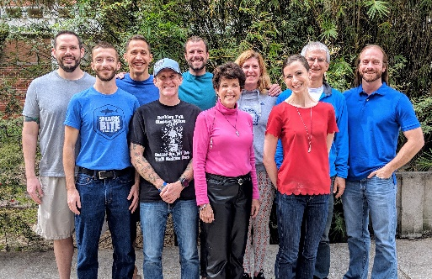
Back row (l-r): Matt Carrillo, Enoch Nadler, Nic Armfield, VP Gretchen Loyd, Konstantin Matchev, President Richard Garand
Front Row (l-r): Dan Stoner, Pat Gallagher, Past President Elizabeth Hanselman, Executive Director Betsy Suda

2018 FTC Board Members
President: Richard Garand, rjgarand@gmail.com

Vice President: Gretchen Loyd, gretchen.loyd@gmail.com

Past President: Elizabeth Hanselman
gainesvillerunwalkrun@gmail.com

Treasurer: Marie Dennis, fsumarie@hotmail.com

Directors:
Patrick Gallagher el.gallagher@gmail.com
Nick Armfield narmfield@gmail.com
Dan Stoner danstoner@gmail.com
Matt Carrillo mattcarrillo@gmail.com
Enoch Nadler teamfloridatrackclub@gmail.com
Konstantin Matchev konstantin.matchev@gmail.com
Mark Ou, markieou@gmail.com

Executive Director: Betsy Suda betsysuda820@gmail.com
Thank you to our generous club sponsor:
http://www.ortho.ufl.edu/

